# EXERCISE 13 – ANDROID GOOGLE MAP

Android provides facility to integrate Google map in our application. Google map displays your current location, navigate location direction, search location etc. We can also customize Google map according to our requirement.

##### Types of Google Maps

There are four different types of Google maps, as well as an optional to no map at all. Each of them gives different view on map. These maps are as follow:

1. **Normal:** This type of map displays typical road map, natural features like river and some features build by humans.
2. **Hybrid:** This type of map displays satellite photograph data with typical road maps. It also displays road and feature labels.
3. **Satellite:** Satellite type displays satellite photograph data, but doesn't display road and feature labels.
4. **Terrain:** This type displays photographic data. This includes colors, contour lines and labels and perspective shading.
5. **None:** This type displays an empty grid with no tiles loaded.

**Example of Google Map**

Let's create an example of Google map integrating within our app. For doing this we select Google Maps Activity.

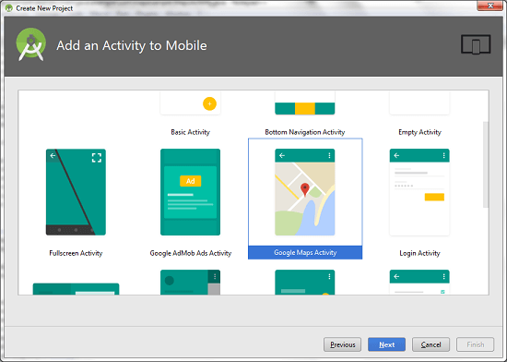

Copy the URL from google_map_api.xml file to generate Google map key.

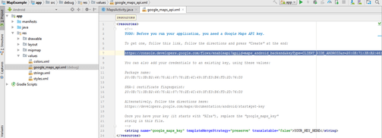

Paste the copied URL at the browser. It will open the following page.

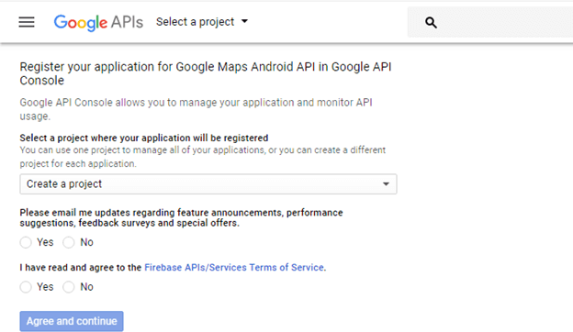

Click on Create API key to generate API key.

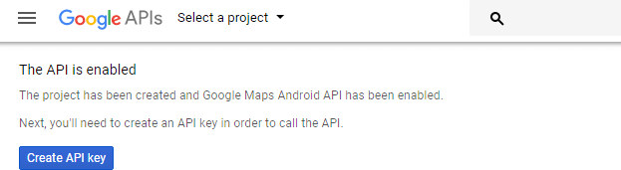

After clicking on Create API key, it will generate our API key displaying the following screen.

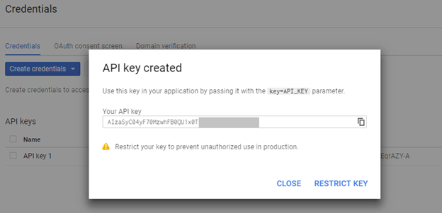

Copy this generated API key in our *google_map_api.xml* file

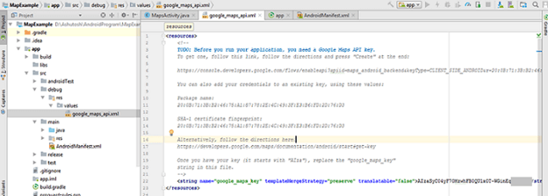

**activity_maps.xml**

<fragment xmlns:android="<http://schemas.android.com/apk/res/android>" xmlns:map="<http://schemas.android.com/apk/res-auto>" xmlns:tools="[http://schemas.android.com/tools"](http://schemas.android.com/tools) android:id="@+id/map" android:name="com.google.android.gms.maps.SupportMapFragment" android:layout_width="match_parent" android:layout_height="match_parent"

tools:context="example.com.mapexample.MapsActivity" />

**MapsActivity.java**

To get the GoogleMap object in our MapsActivity.java class we need to implement the OnMapReadyCallback interface and override the onMapReady() callback method.

package example.com.mapexample;

import android.support.v4.app.FragmentActivity; import android.os.Bundle;

import com.google.android.gms.maps.CameraUpdateFactory; import com.google.android.gms.maps.GoogleMap;

import com.google.android.gms.maps.OnMapReadyCallback; import com.google.android.gms.maps.SupportMapFragment; import com.google.android.gms.maps.model.LatLng;

import com.google.android.gms.maps.model.MarkerOptions;

public class MapsActivity extends FragmentActivity implements OnMapReadyCallback{

private GoogleMap mMap;

@Override

protected void onCreate(Bundle savedInstanceState) { super.onCreate(savedInstanceState);

setContentView(R.layout.activity_maps);

// Obtain the SupportMapFragment and get notified when the map is ready to be used.

SupportMapFragment mapFragment = (SupportMapFragment) getSupportFragmentMan ager()

.findFragmentById(R.id.map); mapFragment.getMapAsync(this);

}

@Override

public void onMapReady(GoogleMap googleMap) { mMap = googleMap;

// Add a marker in Sydney and move the camera LatLng sydney = new LatLng(-34, 151);

mMap.addMarker(new MarkerOptions().position(sydney).title("Marker in Sydney")); mMap.moveCamera(CameraUpdateFactory.newLatLng(sydney));

}

}

**Required Permission**

Add the following user-permission in AndroidManifest.xml file.

1. <uses-permission android:name="android.permission.ACCESS_FINE_LOCATION" />
2. <uses-

permission android:name="android.permission.ACCESS_COARSE_LOCATION" />

1. <uses-permission android:name="android.permission.INTERNET" />

**AndroidManifest.xml**

<?xml version="1.0" encoding="utf-8"?>

<manifest xmlns:android=["http://schemas.android.com/](http://schemas.android.com/apk/res/android)a[pk/res/android"](http://schemas.android.com/apk/res/android) package="example.com.mapexample">

<!--

The ACCESS_COARSE/FINE_LOCATION permissions are not required to use Google Maps Android API v2, but you must specify either coarse or fine location permissions for the 'MyLocation' functionality.

-->

<uses-permission android:name="android.permission.ACCESS_FINE_LOCATION" />

<uses-

permission android:name="android.permission.ACCESS_COARSE_LOCATION" />

<uses-permission android:name="android.permission.INTERNET" />

<application android:allowBackup="true" android:icon="@mipmap/ic_launcher" android:label="@string/app_name"

android:roundIcon="@mipmap/ic_launcher_round" android:supportsRtl="true" android:theme="@style/AppTheme">

<meta-data android:name="com.google.android.geo.API_KEY" android:value="@string/google_maps_key" />

<activity android:name=".MapsActivity"

android:label="@string/title_activity_maps">

<intent-filter>

<action android:name="android.intent.action.MAIN" />

<category android:name="android.intent.category.LAUNCHER" />

</intent-filter>

</activity>

</application>

</manifest>

**build.gradel**

Add the following dependencies in *build.gradel* file.

1. dependencies {
2. implementation fileTree(dir: 'libs', include: ['*.jar'])
3. implementation 'com.android.support:appcompat-v7:26.1.0'
4. implementation 'com.google.android.gms:play-services-maps:11.8.0'
5. testImplementation 'junit:junit:4.12'
6. androidTestImplementation 'com.android.support.test:runner:1.0.1'
7. androidTestImplementation 'com.android.support.test.espresso:espresso-core:3.0.1' 8. }

Output

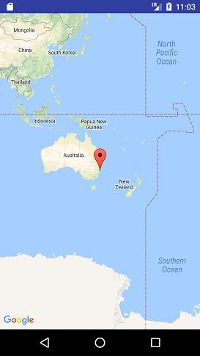

##### EXERCISE 13.1:

Develop an android application to search your current location and add marker to it. [05]

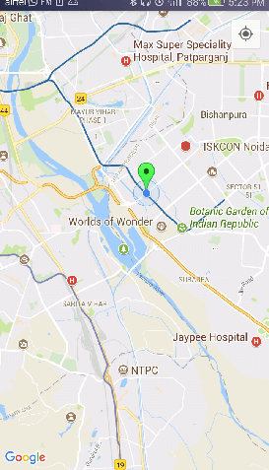

##### EXERCISE 13.2:

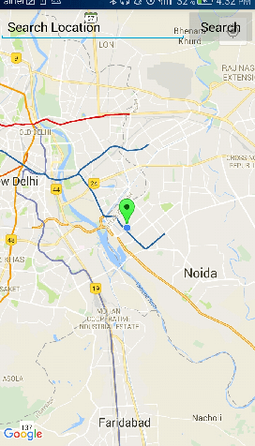Develop an android application to search your current location using Geo coder. [05]

##### RESOURCES:

<https://www.codingconnect.net/mobile-application-development-lab/> <https://www.javatpoint.com/android-tutorial> <https://www.tutorialspoint.com/android> <https://developer.android.com/guide> [Https://developer.Android.com/training/basics/firstapp/creating-project](https://developer.android.com/training/basics/firstapp/creating-project)

[Https://www.raywenderlich.com/120177/beginning-Android-development-tutorial-](https://www.raywenderlich.com/120177/beginning-Android-development-tutorial-installingAndroid-studio) [installingAndroid-studio](https://www.raywenderlich.com/120177/beginning-Android-development-tutorial-installingAndroid-studio) <https://www.youtube.com/playlist?list=PLS1QulWo1RIbb1cYyzZpLFCKvdYV_yJ-E> [Https://www.udemy.com/java-tutorial/](https://www.udemy.com/java-tutorial/)

[Https://www.w3schools.com/xml/](https://www.w3schools.com/xml/) [Http://www.Androidguys.com/](http://www.androidguys.com/)